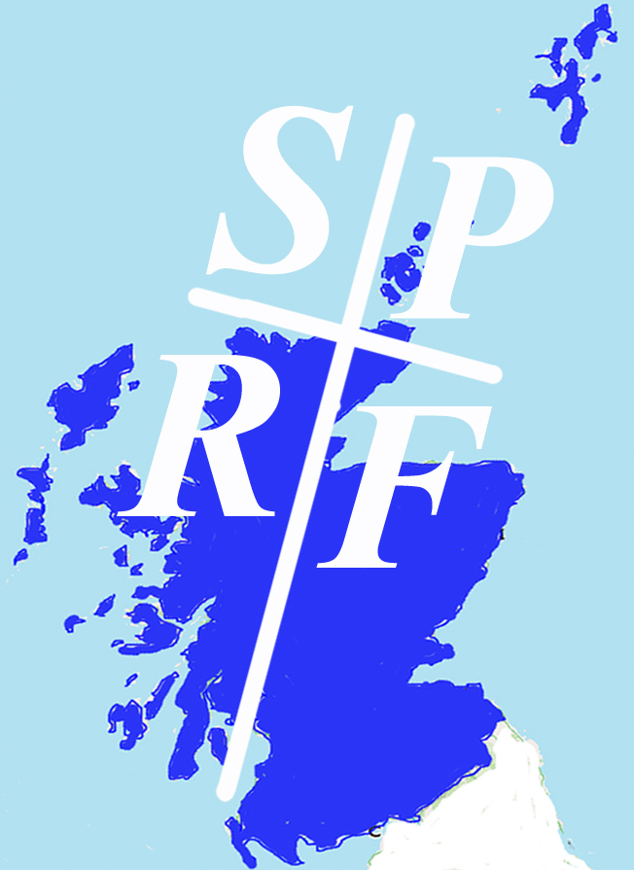
Scottish Pilgrim Routes Forum www.sprf.org.uk
Scottish Charitable Incorporated Organisation SC045212

23 King Street, Doune, Perthshire FK16 6DN
www.sprf.org.uk

Membership Application Form – Organisation

We wish to apply for membership of the Scottish Pilgrim Routes Forum. We attach a summary statement of our interest in the work of the Forum (max 100 words). We consent to SPRF holding the following details on its membership register for the purposes shown below.

Name of organization, group, charity or business (for subscriptions, see below)

……………………………………………………………………………………………………………………………………………………

Designated contact for SPRF correspondence / mailings, if different from administrative contact below:

Name: …………………………………………………………… E mail: …………………………………………………………….

Administrative Contact Details, for annual subscription invoice in future years:

Address: …………………………………………………………………………………………………………………………………….

………………………………………………………………………………………………………… Post Code:………………….

Tel: ……………………… E-mail: ……………………………………….. Website: ……………………………………………

Signed: …………………………………………………………………….. Date: …………………………………….

Position in Organisation ………………………………………………………………………………………………..

Annual subscription: please indicate your organisation’s current level of annual unrestricted income below. (please tick relevant box)

Up to £10,000 p.a. ………………………… annual subscription £30
£10,000 to £100,000 p.a. ……………….. ,, ,, £60
Over £100,000 p.a. ………………………….. ,, ,, £120

Please pay by bank transfer to sort code 08 92 99 account 67214402 or by cheque to ‘Scottish Pilgrim Routes Forum’. Our subscription year runs from 1st August to 31st July. We do not cater for part payment of the first subscription.

Please send this completed form with your supporting statement of interest and bank transfer confirmation / cheque payment to:

Nick Cooke, SPRF Secretary
23 King Street, Doune, Perthshire FK16 6DN Email: secretary@sprf.org.uk

E-mail acknowledgement of your application and first subscription will be provided.

Please be aware that applications for membership are subject to approval by the SPRF Board of Trustees under our Constitution as a registered Scottish Charitable Incorporated Organisation (SCIO). This may result in some delay before you receive confirmation details of your SPRF membership.

